
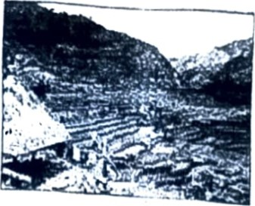
Republic of the Philippines Province of Ifugao
OFFICE OF THE SANGGUNIANG PANLALAWIGAN
Capitol, Lagawe, Ifugao

PROVINCIAL ORDINANCE NO. 2019-14
Explanatory Note
Public Law No. 5 of 1900. an Act for the Establishment and Maintenance ofan Efficient and Honest Civil Service in the Philtppine Island, and Presidential Proclamation No. 1050 s. 1997. declaring the month of September, 1997 and of every year thereafter as "Civil Service Month", had respectively established a system to secure an efficient civil service in the country and provides that, all' agencies, Offices and instrumentalities of govemment shall implement the programs promulgated by the Civil Service Commission and shall actively participate, as well as ensure the active involvement of their officials and employees, in the activities that the Commission may deem necessany for the meaningful and successful celebration of the Civil Service Month.
Pursuant hereto, this ordinance is put Tonvard purposely to institutionalize a regular day and an appropriate means of support for the civil senhce celebration in the Provincial Government of Ifugao
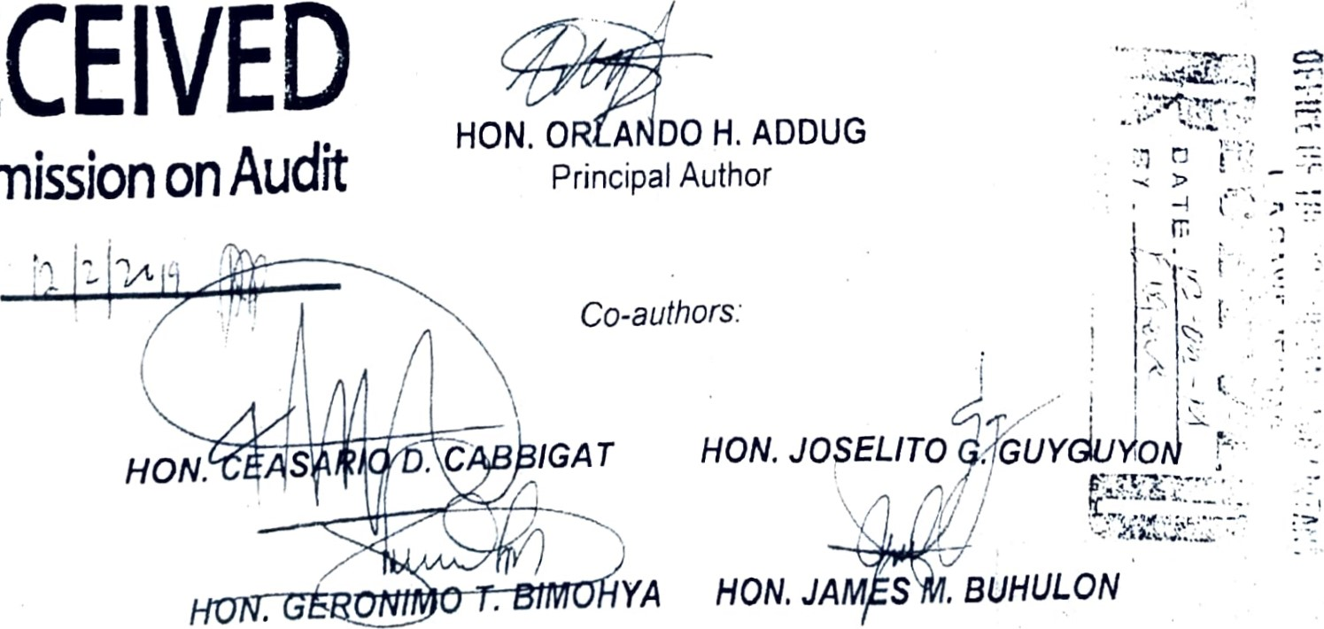Date:
RECEIVED
Commission
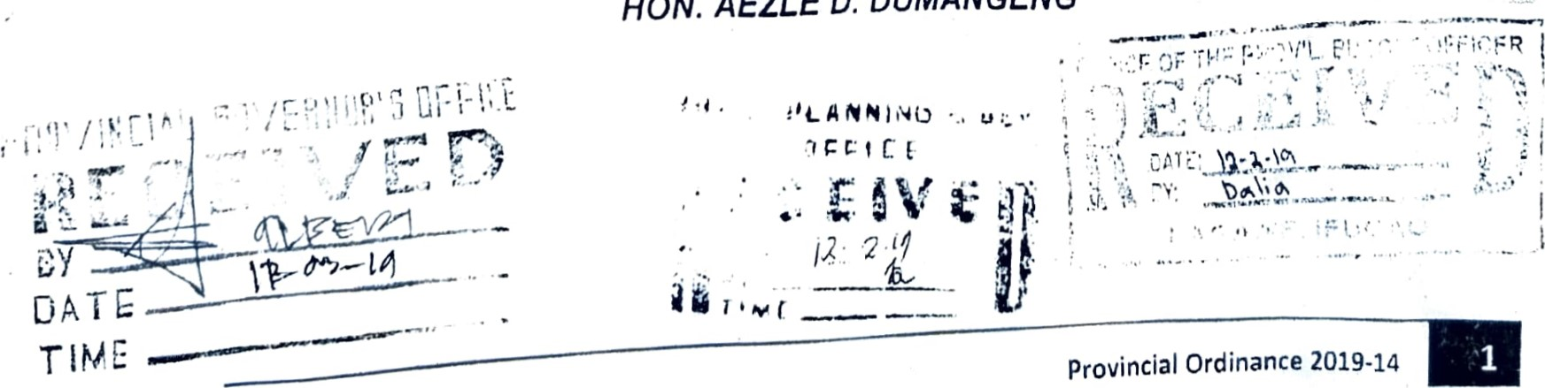
HON.
AEZLE
D.
DUMANGENG

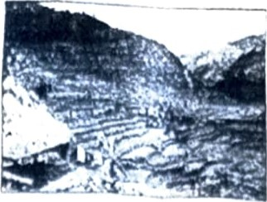
Republic of the Philipptnes Province of Ifugao
OFFICE OF THE SANGGUNIANG PANLALAWIGAN
Capitol, Lagawe, Ifugao

PROVINCIAL ORDINANCE NO. 2019-14
(Principal Author Hon Odando H Addug)
(Co-authors. Hon. Ceasano D. Cabbigat. Hon Joselito G. Guyguyon.
Hon Geronimo T Bimohya, Hon James M Buhu/on, Hon. Aezle D Dumangeng

INSTITUTIONALIZING EVERY LAST FRIDAY OF SEPTEMBER AS CIVIL SERVICE DAY CELEBRATION IN THE PROVINCIAL LOCAL GOVERNMENT UNIT OF IFUGAO AND PROVIDING FUNDS THEREFOR
Be it enacted by the Sangguniang Panlalawigan in session assembled, that:
Section 1. Title. This ordinance shall be known as 'Civil Service Day Celebration In the Provincial Local Government of Ifugao"
Section 2. STATEMENT OF POLICY AND OBJECTIVES. Pursuant to Public Law No 5 of 1900 and Presidential Proclamation No 1050 S 1997, it shall be the policy of the Provincial Government of Ifugao to institutionalize every last Friday of September as Civil Service Day Celebration in the Provincial Local Government of Ifugao purposely to
- Promote meaningful celebration of civil service in the province and provide an appropriate means to support the activities promulgated for this purpose.
- Fortify solidarity among civil servants in the provincial government of Ifugao as well as its attached agencies
c. Uphold public values. and actively work for the total development of the province
Section 3. SCOPE AND COVERAGE. All employees of the Provincial Local Government and its attached agencies are enjoined to attend and participate on the activities promulgated for this purpose
Section 4. FUNDING. The necessary expenses during the celebration shall be charged to the Service Fee Collections pursuant to Provincial Ordinance No. 2019-04 and subject to a Work and Financial Plan as recommended by the Local Finance Committee and approved by the Provincial Governor
Section 5. IMPLEMENTATION. The Human Resource and Management Office is empowered to lead the implementation of this celebration. The office may call meetings of all representative of the respective stakeholders necessary to develop plans and activities which may further strengthen the abovementioned objectives of this ordinance
Section 6. SEPARABILITY CLAUSE. If any provisions or part of this ordinance is held Invalid the remainder of the provisions or part of this ordinance shall remain to be in full force and effect
Section 7. REPEALING CLAUSE. All executive orders, memoranda or other issuance or any part thereof which are inconsistent herewith are hereby repealed or modified 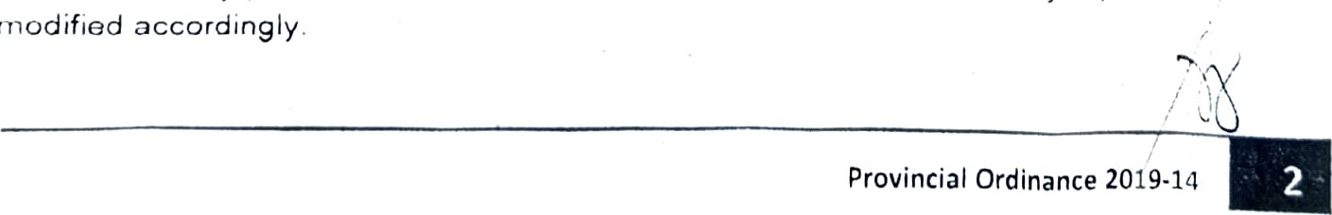accordingly

Section 8. EFFECTIVITY CLAUSE. This Ordinance shall take effect upon Its approval

Pan'alawigan
ENACTE
D
AN
D
APPROVED
by
the
Sanggun,ang
day
ORLAND?
Member Member
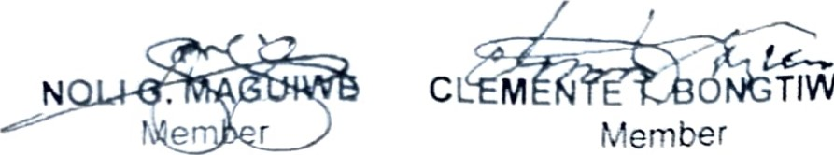
(cn Offic'ai Busness:
TIWON

MAXIMILLAN D. LUGLUG Membe-
(cn Officjat Bus:ness
JAMES M. BUHULON | AEZLE D. DUMANGENG Member
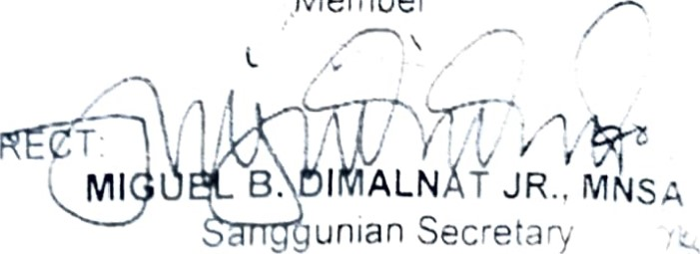
Member
CERTIFIED COR
ATTESTED BY

GLEN P UDENCIANO
Vice-Gov r or a d Presiding Officer
APPROVED: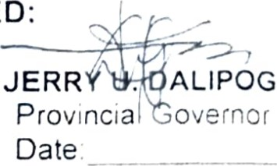
Provincial Ordinance 2019-14

